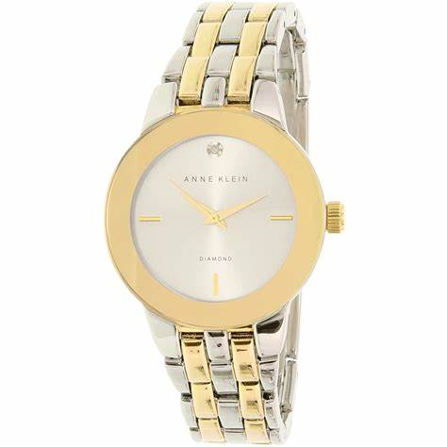Annie klein

Description: **Anne Klein** is a well-known fashion brand offering stylish and affordable women's watches that combine elegance with everyday practicality. Unlike luxury Swiss watchmakers, Anne Klein focuses on **fashion-forward designs** with **quartz movements**, making them a great choice for women looking for trendy, reliable, and budget-friendly timepieces.

Anne Klein watches come in a variety of styles, from **classic dress watches** with slim bracelets and minimalist dials to **bold, modern designs** featuring ceramic, leather, or mesh bands. Many models include **gold-tone, rose gold-tone, and silver-tone finishes**, often embellished with **crystals from Swarovski** for a touch of glamour. Some designs also feature **mother-of-pearl dials, Roman numerals, and diamond accents**, making them perfect for both casual and formal occasions.

One of the brand’s standout features is its **bangle and bracelet watch sets**, which pair a stylish watch with coordinating bangles, creating an effortless stacked look. These sets are perfect for women who love accessorizing with matching jewelry.